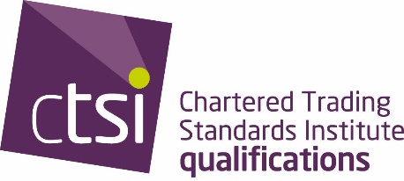 | Leading the trading standards profession

Qualification Framework Trading Standards Advanced Practitioner Project - EMPLOYER APPROVAL FORM

It is important that your employer has given their support for your project. If your project includes practical enforcement, your Local Authority/employer must indicate they are willing to resource you to do this.

Your employer must also be satisfied that the project you are proposing, is ethical and that any data protection requirements are set in place.

Candidate Information
Full Name: |  |  |  |  |  | Candidate No
 | Last | First
Authority: |  |  | Email:

Line manager/Head of Service Information

In signing this form, you are confirming that you will ensure all ethical and data protection requirements have been considered and that all precautions have been taken with any data collected. That resources have been made available to the candidate named above.

Full Name:
 | Last | First
Authority/Job Title: |  |  | Signature:

Project Information

Provisional Title

