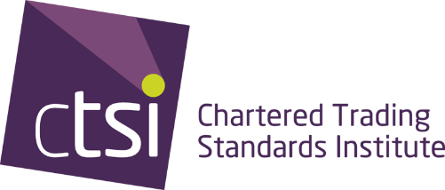

Chartered Trading Standards Institute (CTSI) response to HM Treasury’s consultation on “A Streamlined Approach to Payment Systems Regulation”
Response sent to – streamlinedpaymentsconsultation@hmtreasury.gov.uk
This response is being sent on behalf of The Chartered Trading Standards Institute and has been compiled by the expertise of CTSI members.
ABOUT CTSI
Founded in 1881 (as the 'Incorporated Society of Inspectors of Weights and Measures'), today's Chartered Trading Standards Institute (CTSI) is one of the world’s longest-established organisations dedicated to the field of Trading Standards and Consumer Protection.
At CTSI, and through the Trading Standards profession, we aim to promote good trading practices and to protect consumers. We strive to foster a strong vibrant economy by safeguarding the health, safety and wellbeing of citizens through empowering consumers, encouraging honest business, and targeting rogue practices. We provide information, guidance and develop evidence-based policies and campaigns to support local and national stakeholders including central and devolved governments. CTSI also provides the secretariat to the All-Party Parliamentary Group on Consumer Protection and campaigns on range of topics including product safety issues. CTSI is responsible for business advice and education in the area of Trading Standards and consumer protection legislation, including running the Business Companion service to provide clear guidance to businesses on how to meet their legal and regulatory obligations.
CTSI is also contracted to provide administrative support to the Approved Codes Scheme which was established to give consumers greater confidence when they buy from members of the approved scheme and also raises the standards of trading of all businesses that operate under the relevant Approved Code for that sector.
CTSI run training and development events for both the Trading Standards profession and a growing number of external organisations. We also provide accredited courses on regulations and enforcement.

RESPONSE
CTSI welcomes the opportunity to respond to HM Treasury’s (HMT) consultation on a streamlined approach to payment systems regulation. CTSI is the UK’s professional membership body for people working in Trading Standards.
In recent years, the Trading Standards profession – particularly the National Trading Standards Scams Team – has worked extensively with the Payments Systems Regulator (PSR) on the design, implementation and monitoring of the Faster Payments Authorised Push Payment scams reimbursement requirement. The new scheme has provided welcome protection for victims and the PSR’s data shows the impact this is having, with 86% of money stolen through APP scams returned to victims in the first three months after implementation. 14% of those claims were made by consumers with a vulnerability. More payment firms are reimbursing scam victims, and there is a strong incentive for all PSPs to prevent fraud.
While CTSI has limited views on the transfer of regulation and the means to achieve that, CTSI urges HMT to ensure that recent improvements in fraud prevention and protections for victims are not lost or deprioritised as part of this move.
In relation to the new regulatory objectives that the FCA should have, it is not clear whether fraud prevention and protection will play a role. This would be a shortsighted omission, and CTSI urges HMT to ensure fraud prevention and/or consumer protection should form part of an explicit objective for the FCA.
CTSI’s network of Lead Officers, who possess specialist expertise in this area, would welcome the opportunity to discuss our response further.

