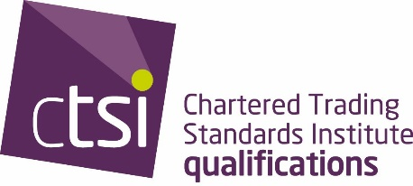 | Leading the trading standards profession

Qualification Framework Assessment of Prior Learning

Candidate Prior Learning Submission Form

Candidate Information

Online APL Registration completed
Full Name:
 | Last | First
Mobile Number: |  |  | Email:

Exemptions being claimed

Please indicate below which exemptions you want to gain recognition in via the prior learning process.

STAGE 1
Exemption

Unit 1 | Regulatory Environment & Enforcement
Unit 2 | Business & Consumer Legal Frameworks
Unit 3 | Trading Standards Law Part 1

STAGE 2

Unit 4 | Weights & Measures written / practical / oral only
Unit 4 | Food Standards written / oral only
Unit 4 | Feed written / oral only
Unit 4 | Product Safety
Unit 5 | Investigations

Please note: if claiming for a Practical/Oral assessment, ensure you have made it clear on your application.

Personal Data

The Chartered Trading Standards Institute (CTSI) will use any personal data supplied by candidates or their employers solely for the purpose of the Qualification Framework registration and qualifications.

Personal data will only be retained and shared within the CTSI group of companies, and any of our suppliers as appropriate, in fulfilling CTSI’s obligation of providing those qualifications services and complying with any financial and regulatory requirements.

Your personal data will be processed in compliance with data protection legislation. For more details, please visit our data protection polices and your rights page at: https://www.tradingstandards.uk/about-ctsi/data-protection or email dataprotection@tsi.org.uk.

Further Communication

From time to time we would like to contact you (or your organisation) via email with further and future developments within the qualification. If you would not like to be contacted regarding this please email the qualification team: qualifications@tsi.org.uk

Disclaimer and Signature

PLEASE NOTE: Candidates are responsible for updating CTSI in writing of any change to personal details. Incorrect information may lead to a delay in receiving results.
On signing this document, you are agreeing to the CTSI Professional Competency Framework regulations. A copy can be found on our website:

Signature: |  | Date:

Submission information

Evidence reference form
Full Name: |  |  |  | Candidate No

Section to be filled out by Candidate |  |  | Section Completed by Reviewer
Evidence No. | Subject | Learning outcome | Evidence Inc. Yes/No | Met Learning Outcome? Yes/No

Reviewer to complete:

I confirm that the candidate has proven they have kept their knowledge up to date. Signature: _______________________________ Dated: ____________________

The candidate has not met the evidential requirements. Signature: _______________________________ Dated: ____________________

2nd Reviewer to complete (if required):

I confirm that the candidate has proven they have kept their knowledge up to date. Signature: _______________________________ Dated: ____________________

The candidate has not met the evidential requirements. Signature: _______________________________ Dated: ____________________

