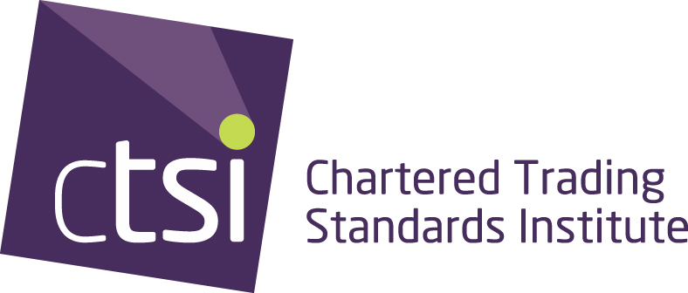

Trading Standards Institute Ltd
A company limited by guarantee
Registered No. 38769
itsa Ltd. 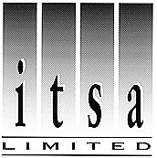

- Separate Company. Wholly owned by TSI. Company limited by shares.
Registered No. 2767942

STRUCTURE OF CTSI

Memorandum Articles of Association and By Laws laid down by Companies Act & members at general meetings e.g. AGM

President appointed annually
COUNCIL

- 3 Nationally elected members (every three years).
- 17 Branch/Society Representatives.
- 4 Officers, Chair, Vice Chair, Immediate Past Chair, 2nd Vice Chair

Standing Orders, Financial Regulation.

Appoint other officers

CHIEF EXECUTIVE

- Runs Institute & both companies on behalf of Board & Council.

- Manages staff at CTSI/itsa office (Separate staff information & chart in Membership Information Directory, TS Directory & on web site).

BOARD

- 3 Executive Directors
- 7 Non-Executive Directors
- Company Secretary (non voting)
- 3 ex officio members (permanent):
Chair, Vice Chair & Immediate Past Chair of CTSI.
- Normally a maximum of 13, but could have extra Associate Directors.

Business Decisions, Policy Management
Appoint Chief Executive.

Lead Officer Groups, Branches, Association of Chief Trading Standards Officers, Society of Chief Officers of Trading Standards in Scotland, Consumer Empowerment Alliance, Business Members Group, Members
Vice Presidents
Review Committees:

- Audit and Finance
- Remuneration and Appointments
ACTSO Ltd (National Trading Standards Board)

Consumer Codes Approval Board cic

