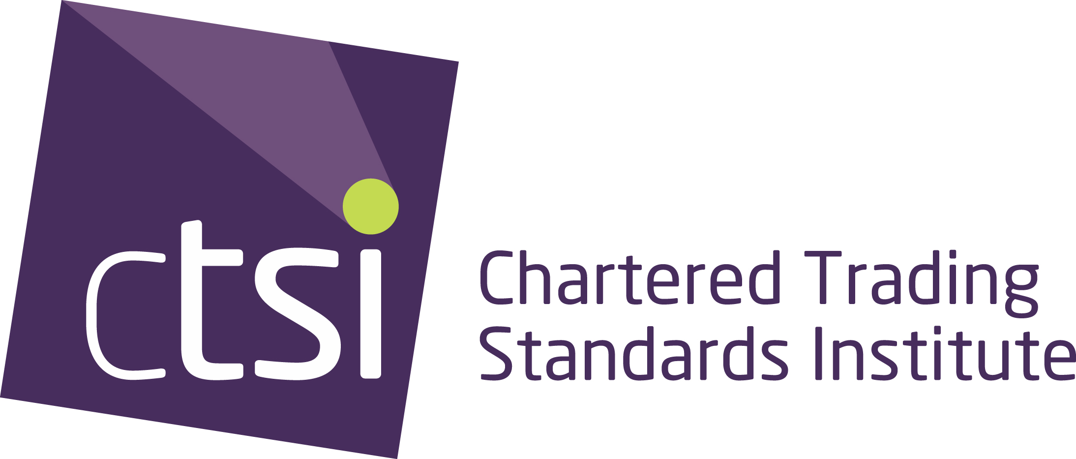

# Stage 3 candidate guidelines

hetetehetehere

Before commencing with this area, you will need to read through the following guidelines to ensure you have followed all procedures correctly. You are also required to be familiar with the CPCF regulations.

**Registration**

* You must be registered with CTSI first as a Stage 3 candidate.
* All registrations are completed on-line. <https://bit.ly/3dNvjJ0>
* For information on the fees associated with Stage 3, please read the **CPCF Stage Fees** document which can be found on the Training and Exams tab. The following link will take you to the correct area. <https://bit.ly/37dBcwJ>
* There are **no** exemptions available for this stage.
* CTSI will confirm you are eligible to complete this stage via email. This letter will be emailed to you, using the email address supplied with your booking.
* You will be required to read through and sign the Academic Misconduct and Integrity Statement form.
* Set up your own Microsoft account (if you do not have one already). CTSI will set up your own SharePoint area that you will use for submitting your project proposal form as well as your completed project.

For information on this, please use our SharePoint guide found on the Stage 3 area (use following link): <https://bit.ly/30jECe6>

It is important that when you supply your project proposal to CTSI via SharePoint, that you also provide the signed Academic Misconduct and Integrity Statement.

**Reading**

* Prior to completing the project proposal form, you must read through the **Unit 7: Trading Standards Advanced Practitioner Handbook**. The handbook provides guidance on how to complete the 8,000-word project. This includes what you will need to do and the evidence you will need to provide with your project proposal.
* You should also download the **Unit 7: Research Methods Guide**. The guide outlines information on research methodologies, including what type of methodology you should use for your project. Is it Qualitative or Quantitative? Read this guide prior to starting the project proposal.

**Support/mentor**

* It is expected that your employer will nominate a person/mentor (or if your employer is not supporting you through Stage 3, you will find a or colleague/peer) who will provide you with support during the process of compiling your project.
* The mentor will act in an advisory capacity, **but will not undertake any of the work associated with your project**. [See Unit 7: Mentor Guide].
* This person, where possible, will have an expertise in the subject area you are covering within your project.
* You will ensure your mentor is aware of their role during this process and have read the guide.
* You and your mentor will complete the Candidate Progress Log and include with your final submission.

**www.tradingstandards.uk** CTSI incorporated by Royal Charter reg.no. RC000879

**Project Proposal**

* Your project should be of benefit to your authority, your region or the profession overall.
* Once you have read through the handbook and guide and confirmed the subject you want to base your project on and the specifics of what you are looking at, you will need to complete the **Unit 7: Project Proposal Form**.

You can download the proposal form from off the Stage 3 area on the website. Use previous link.

* Ensure you complete it in accordance with the handbook.
* You should discuss and seek approval from your employer on the subject area you want to cover, you must gain their approval as part of this process.
* When your employer has approved your choice of subject, they are required to complete the   
  **Unit 7: Employer Approval and Support Form**. This must accompany your proposal form.
* Have you got all your consent forms? You must provide these with your project submission form.

**Timelines**

* There are two submission points each year.

**For project proposal form submissions:**

1 April [each year] OR 1 September [each year].

**For project submissions:**

1 May [each year] OR 1 October [each year].

Depending on which submission point you aim for, will determine when your project will be marked and the outcome taken to the exam boards for ratification.

* Once your project proposal is signed off, you will have **1 year** to complete your project.   
    
  For example, if you submit your proposal for 1 September 2020 and it is agreed, then we will expect your completed project no later than 1 October 2021.

**Submissions**

* Candidates will have available to them three attempts to complete Stage 3.
* If you fail to submit your project at the designated deadline, this will be deemed a fail.
* You will be given a second submission deadline by the Education Team. If you fail to submit to this deadline, this will be deemed a fail.

To submit the portfolio for your third attempt, this will be at the next published deadline as outlined in the Timelines section. If you fail to submit the project for the final deadline, you will have failed Stage 3.

You can choose to re-register for Stage 3 and begin the process again. You will be liable to pay the appropriate fee at that time. You can choose to re-submit your original project proposal form and have it re-approved, or you can choose a new area to look at.

* If you miss the project proposal submission deadline, you will have to wait until the next submission point.
* Should you fail the project, the examiner will provide you with feedback on how you can rectify the issues. This will be specific to the areas the examiner feels needs further work.
* Any mark under 40% is deemed a fail.

**Re-submissions**

* Where the examiner feels there is a minimal deficiency within your project that could be easily rectified, you will be given two weeks to re-submit your updated project. The examiner will provide you with basic feedback on what you need to concentrate on to improve your submission.

If the examiner feels that there is substantial work required still on your project, this will go through the normal process of marking and the final mark will be taken to the boards for ratification. You will be able to re-submit at the next submission point.

* On resubmitting your work, this will be re-examined and moderated.
* Your mark will be taken to the next available ratification meeting.
* If you are unsuccessful on the re-submission of project, you will be provided with a final date to submit your work again. If you do not achieve a pass, you will have failed Stage 3.

You can choose to re-register for Stage 3 and begin the process again. You will be liable to pay the appropriate fee at that time.

**Capping of marks**

The following sets out where capping will occur. All effort should be made in avoiding this outcome.

* If you miss any deadline whether for initial submission or re-submission of your completed project, your final project mark, if passed, will be capped at 40%.
* If the project is submitted and the examiner/moderator can clearly see that it is not ready for submission, the following will occur:
  + You will lose one of the three attempts allowed;
  + Your project will be marked and moderated and if the project does not achieve a mark of 40% or above, this will be failed.
  + Feedback will be provided on what is required to bring the project up to standard.
* If your project is required to be re-submitted, it will be capped at 40%.
* Your project has a specified word count. You are given an allowance on that word count +/-. If your final word count is outside of this word count allowance, your

**Ratification**

* Once the marks from the projects are supplied to CTSI, these will be prepared for ratification at the next available ratification meeting. These meetings occur in July and December of each year.
* You will be notified via email one week after the ratification meetings of your final mark. Where you have passed, a second letter is sent to you notifying you have passed Stage 3. A certificate will be produced and sent to you approximately one month after all examination cycle processes have been completed.

**IMPORTANT – ELECTRONIC STORAGE**

**It is important to note that loss of material due to computing error and/or corruption of storage media, will not be grounds for receiving an extension to the submission deadline.**