How to register for assessments – DCATS Qualified Additional Unit Exam Registration
Please note: at the end of this guide, you will have registered to complete one or more of the following: written exam; coursework submission; portfolio submission; practical exam; oral exam; professional interview.
Please refer to the guide ‘How to book onto a Training Together training course’ to book training courses separately.

Head to the Training & Development page on the CTSI website, then go onto the Professional Competency Framework (CPCF) page via the following link: https://www.tradingstandards.uk/practitioners/training-development/professional-competency-framework-cpcf
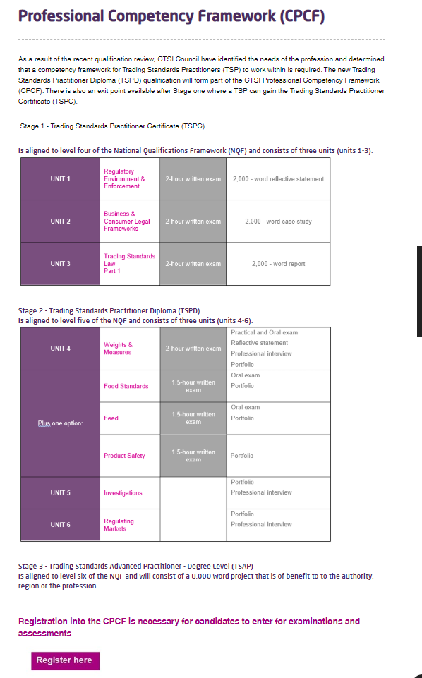

Click the ‘Register here’ box under the Stage information.

On the Online Event Booking form, click the ‘Click here’ link beside the assessment you wish to book:
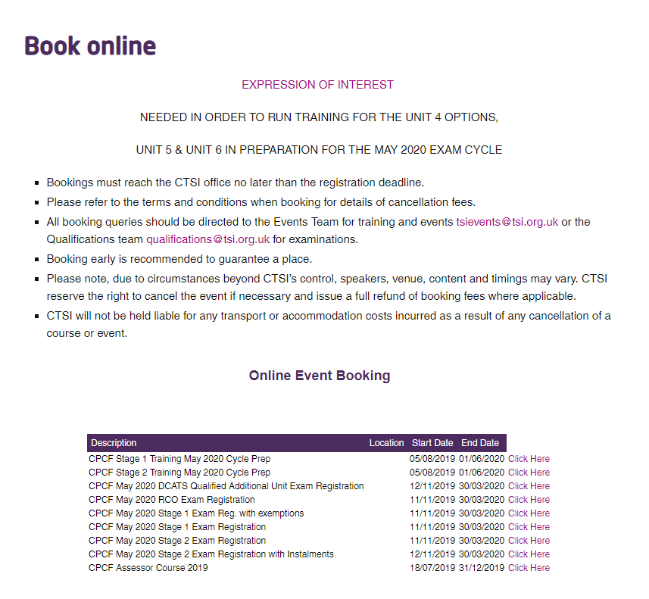

You will land on the login page below.
Members (or previous members) are to enter the email address registered with CTSI into the 'Username' box. They should then enter their six-digit member number into the 'Password' box:
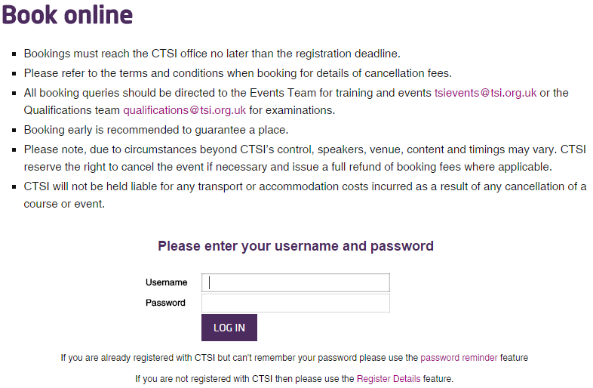
Members (or previous members) do have the option of sending a password reminder to the email address registered to CTSI (it's always best to check this if the candidate is unsure whether they are registered to CTSI, so as not to create duplicate records).
This will enable you to register for an exam, and indicate whether the candidate will be self-funding or if their local authority will be paying. When you have done this, click 'Continue':
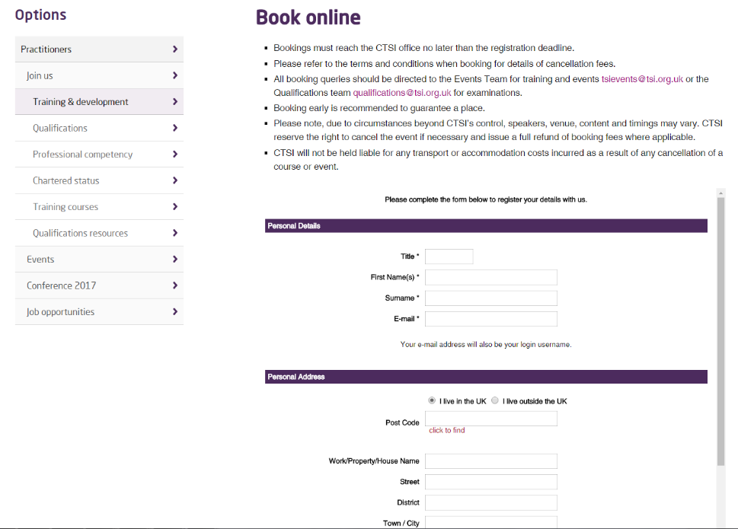

The next screen asks for the details of the booking contact. The booking contact is the person entering for an assessment. These details are entered automatically but are editable, so ensure the details are correct, supply a purchase order number and click 'Continue’:
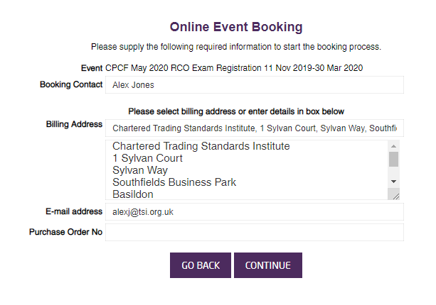

On the next screen, select the registration button using the '+' button, then click ‘continue’:
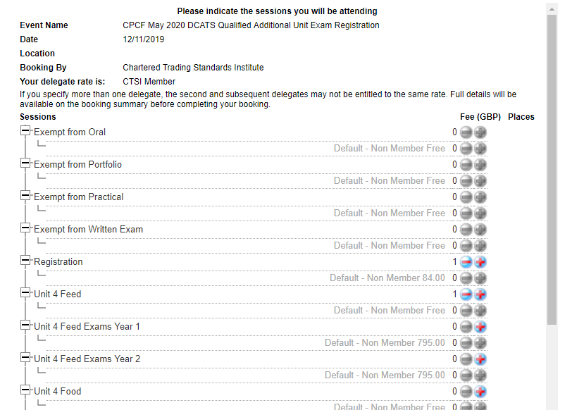
On the next page, the system will have inputted the name of the candidate who will be completing assessments.
This is already completed due to you now only being able to book yourself onto assessments and not multiple people.
Ensure these details are correct and click 'continue':

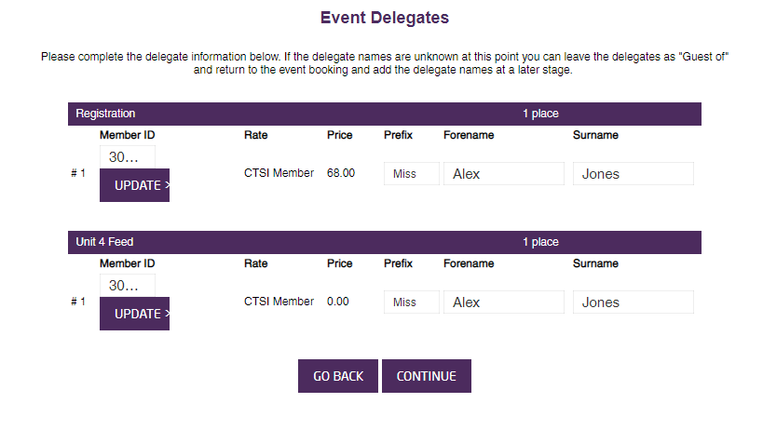

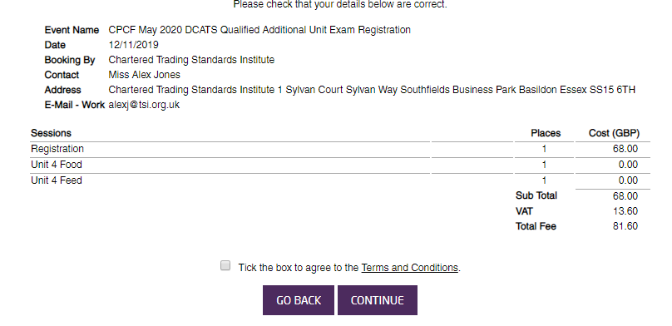
On the final page, select the box to 'agree to the Terms and Conditions' and click 'continue':

You will then see this pop up informing you that you will shortly receive an invoice, and providing a number to call if you wish to pay by card:

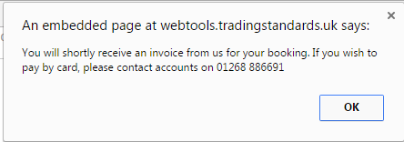

Your booking is complete.

