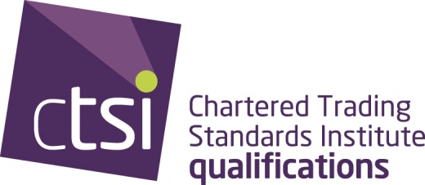

Appeals
Appeals meeting is held after the exam boards and the results letter has been posted. This document outlines the process. The Appeals Panel is an independent group that are separate to the main qualifications processes.

Why should
you appeal?

When can you
appeal?

Only you can decide if you should appeal. If you choose to go ahead, your reasons for appealing must be based on your performance on the day of the exam(s). Was it affected and how?

Your appeal may be turned down if you provide insufficient information.
Make sure you give as much supporting information and detail available to you.
You have 21 days from the date of your letter to send in your appeal
- your appeal will be presented to the panel for discussions
- a letter will be posted to you outlining the Panel's decision within 5 days of the meeting.
If it is not upheld, you will be given their reasons
- appeal received within 20 days of date on result letter
- address FAO Policy Director marked Private and confidential
- See page 4 for types of evidence
- covering letter explaining the circumstances
- purchase order or cheque - this fee is non refundable
- email the team
- the team are there to help answer your questions
- you must decide whether to appeal or not - the qualifications team cannot tell you what to do

Who are the
appeals panel?
The members of the appeals panel are made up of different factions associated with both CTSI and the profession.
- CTSI Chief Executive (Chair)
- Member of the College of Fellows
- Chair of CTSI
- Immediate past Chair of CTSI
- Member of the Chief Officer Section
This group is supported by a non-voting member of the QAB. The qualifications team will also provide support as necessary.

How will my appeal
be presented?

The qualifications team collate together any appeals received and set this out in a document that clearly indicates the information contained for each appeal. All supporting information is set out in this document.

Is it confidential?

Details regarding an appeal can be of a personal nature. Any appeal received is kept confidentially and locked away, only the appeals group and the qualifications team are aware of the content.

What happens if
I don't agree?

Candidates have two opportunities to supply information regarding circumstances that affected them on the day of their exam(s).

Types of evidence

What else do I
need to know?

When the appeals panel confirm that your circumstances did affect your performance, your mark is not changed to a pass but a note is added to it to confirm that an appeal has been heard and upheld. You won't receive a new results letter.
When can't
I appeal?

Appeals are not seen by the panel when they are based on academic judgement.
Appealing on the basis that you achieved 38% (only 2% off the pass mark) is not a reason that the appeals panel will see your appeal, nor will they see your appeal because you do not agree with the result achieved.
Before your results are posted to you....
your results will have been individually and collectively moderated. The Examinations and Assessments Board (EAB) meet to ensure that all processes have been completed to theirs and the Qualifications and Awards Board (QAB) standard. CTSI report to the EAB on all exam processes and highlight any issues they are aware of.

Should you have reason to believe that your mark is not correct please write to the Chair of the QAB c/o CTSI. Your letter will be forwarded to them and you will receive confirmation of receipt. The Chair of the QAB will write to you once they have reviewed your letter.

