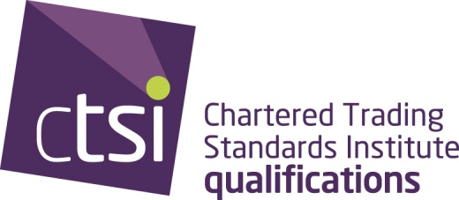

PAST PAPERS AND REPORTS
The last three years' papers and reports can be downloaded below. To try and ensure knowledge gained from revision papers is current, the papers listed below are all we are making available.
You can also view a results summary from the Examination and Assessment Board.

November 2015 exam papers and reports:
subject /paper | report
legal systems | legal systems report
law of contract | law of contract report
consumer protection environment | consumer protection environment report
advice resolution and redress | advice resolution and redress report
agriculture | agriculture written exam report  agriculture practical and oral report
animal health and welfare | animal health and welfare report
fair trading civil | fair trading civil report
fair trading criminal | fair trading criminal report
food standards | food standards written exam report  food standards oral report  food standards practical report
intellectual property | intellectual property report
intelligence and investigative principles | intelligence and investigative principles report
legal metrology technology | legal metrology technology report
legal metrology law | legal metrology law report
 | legal metrology practical and NMRO oral exams report
product safety | product safety report

November 2014 exam papers and examiners' reports
subject /paper | report
legal systems | legal systems report
law of contract | law of contract report
consumer protection environment | consumer protection environment report
advice resolution and redress | advice resolution and redress report
agriculture | agriculture written exam report (not received)  agriculture practical and oral report
animal health and welfare | animal health and welfare report
consumer credit | consumer credit report
fair trading civil | fair trading civil report
fair trading criminal | fair trading criminal report
food standards | food standards written exam report (not received)  food standards oral report  food standards practical report
intellectual property | intellectual property report
intelligence and investigative principles | intelligence and investigative principles report
legal metrology technology | legal metrology technology report
legal metrology law | legal metrology law report  legal metrology practical and oral exams report
product safety | product safety report

November 2013 exam papers and examiners' reports
All documents are in PDF format
subject/paper | report
legal systems | legal systems report
law of contract | law of contract report
consumer protection environment | consumer protection environment report
advice, resolution and redress | advice, resolution and redress report
agriculture | Written report not supplied by examiner, we apologise for this inconvenience.  agriculture oral report  agriculture practical report
animal health and welfare | animal health and welfare report
consumer credit | consumer credit report
fair trading civil | fair trading civil report
fair trading criminal | fair trading criminal report
food standards | Written report not supplied by examiner, we apologise for this inconvenience  food standards oral report  food standards practical report
intellectual property | intellectual property report
legal metrology technology | legal metrology technology report
legal metrology law | legal metrology law report  legal metrology practical and oral report
product safety | product safety report

Past papers for Food Standards practical exams are also available.

